**Cloud(AWS) Week 1 Task:**

❖ Prerequisites: Create your free-tier AWS account.

❖ Task: Deploy application in monolithic and microservices architecture.

❖ Description:

* For monolithic : 1 EC2 instance, deploy wordpress and MYSQL on the same instances.

**Screenshots:**

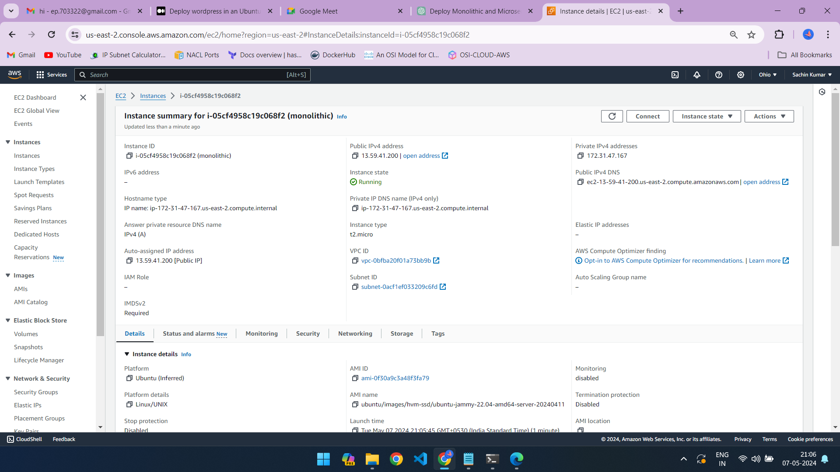

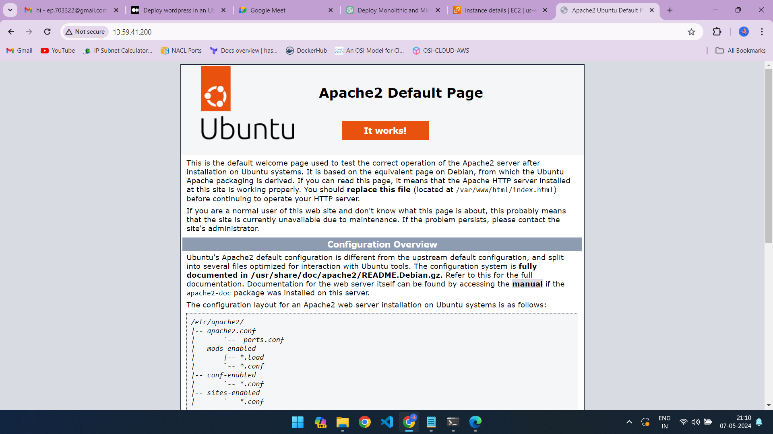

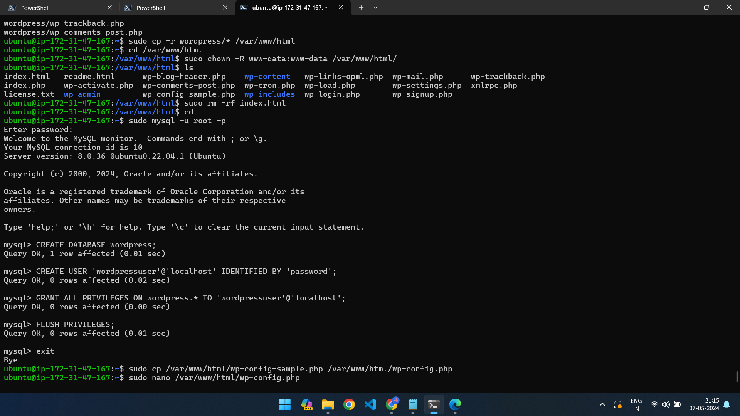

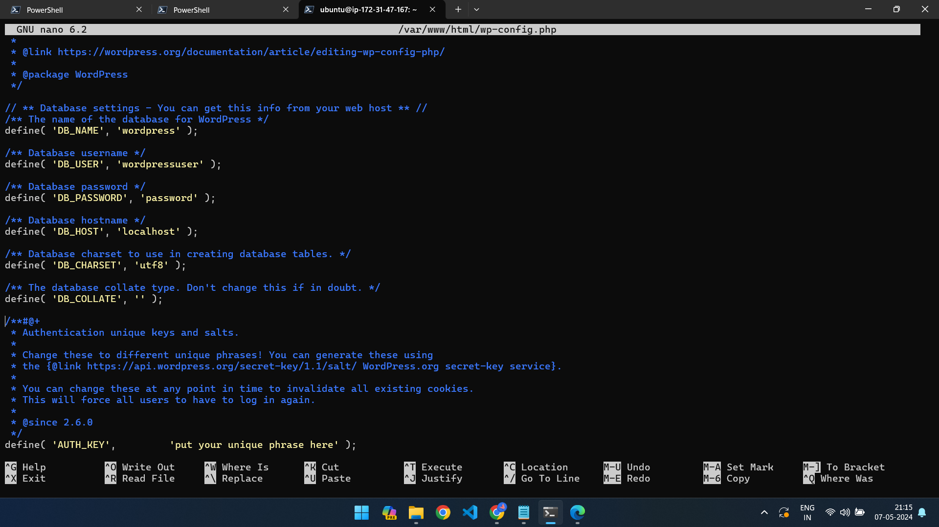

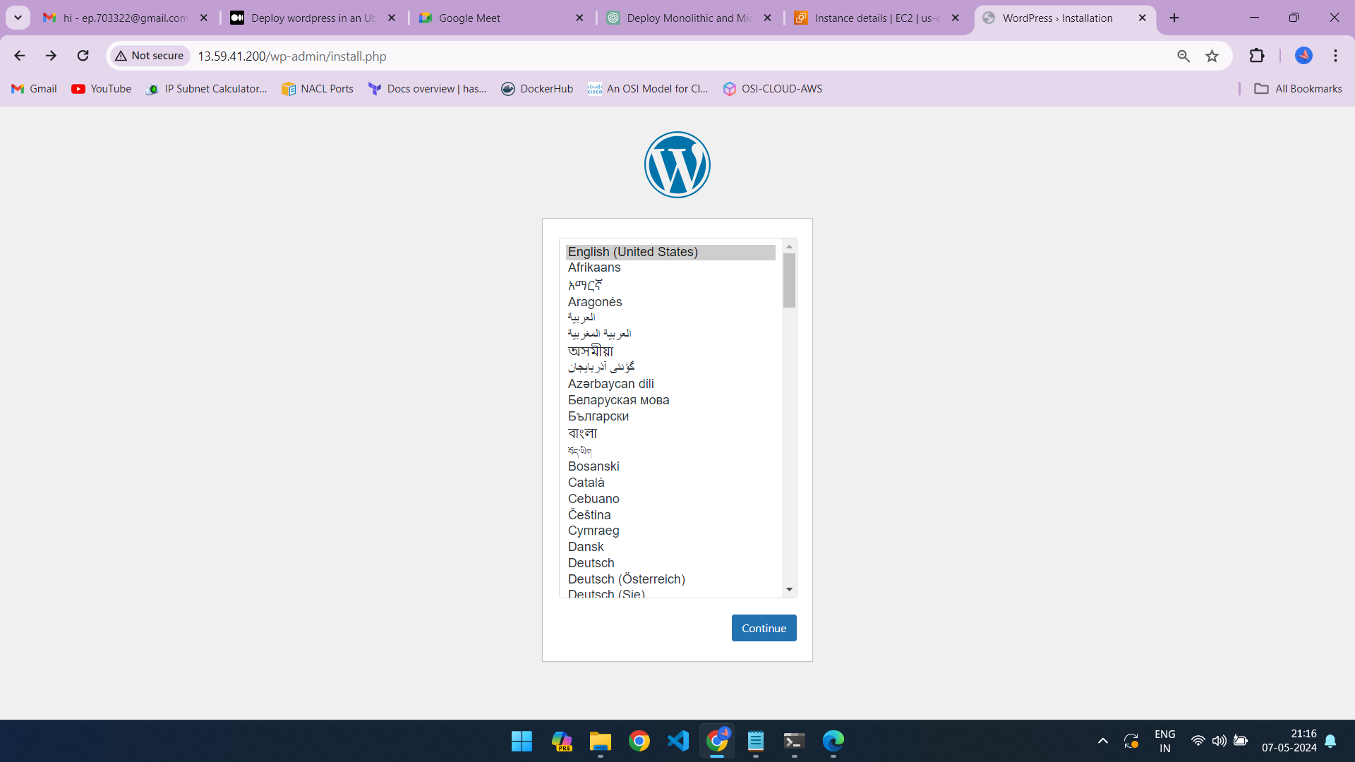

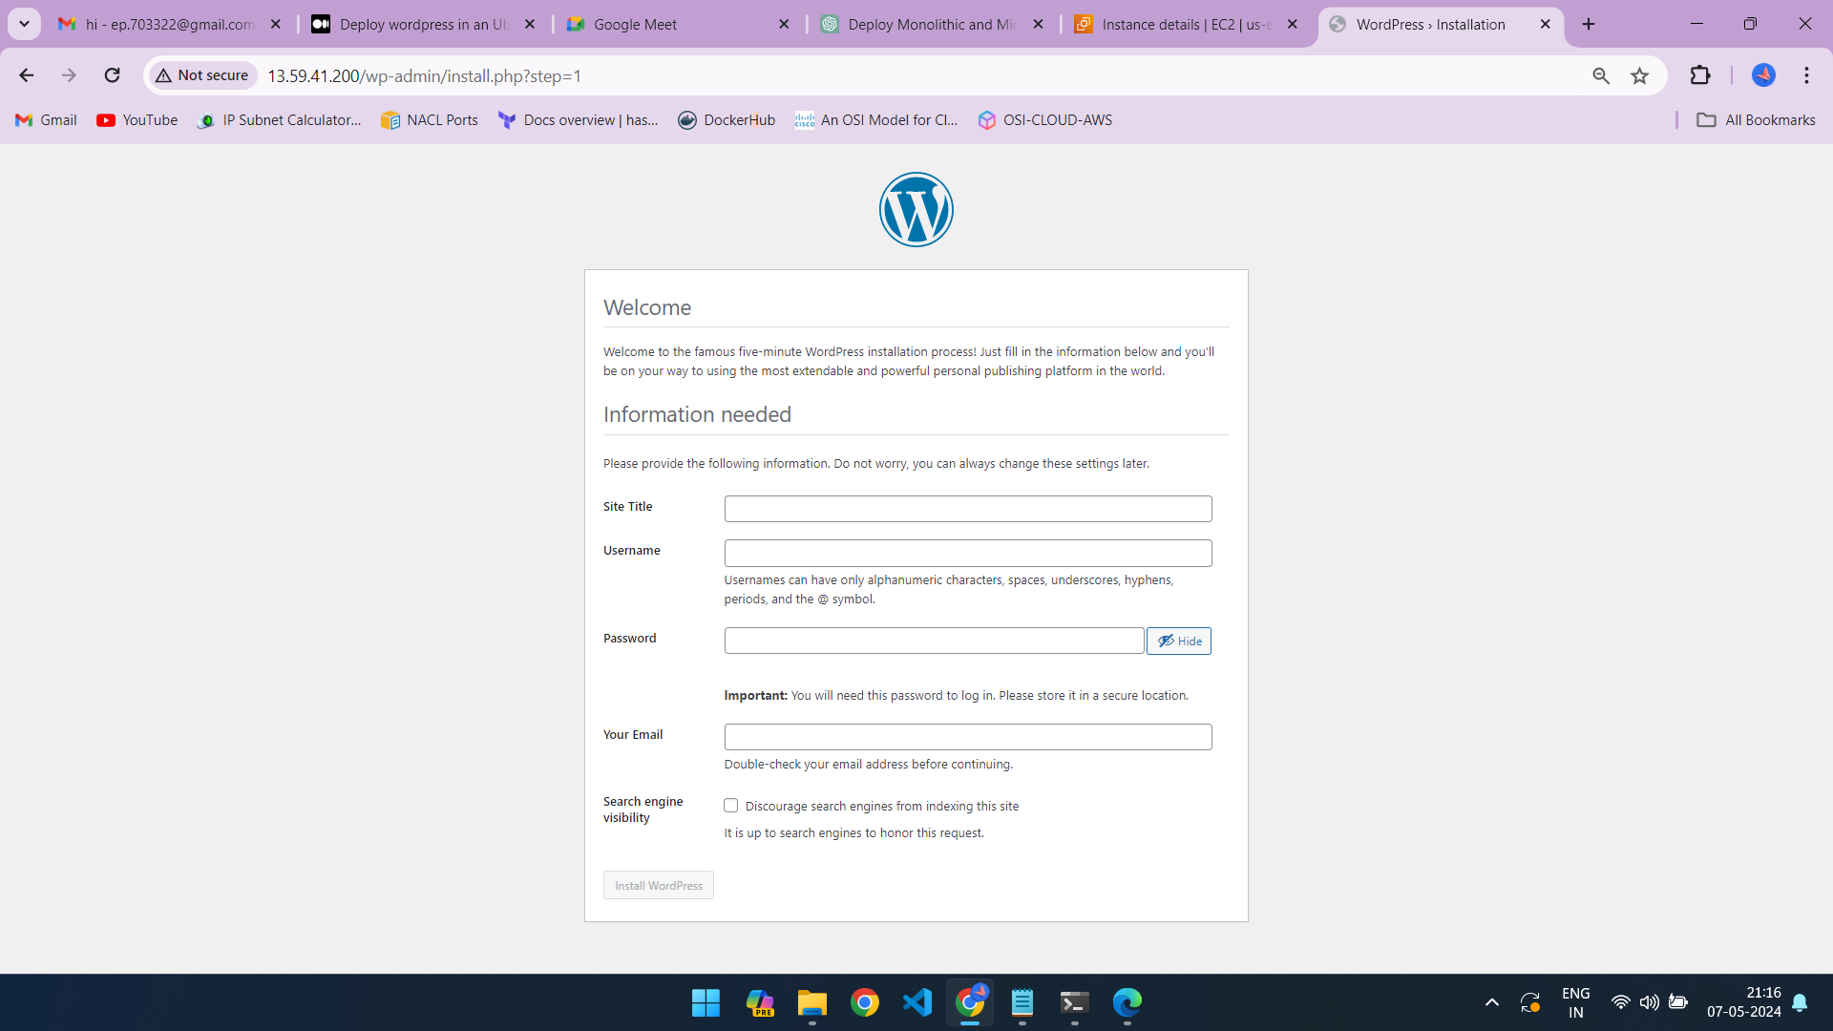

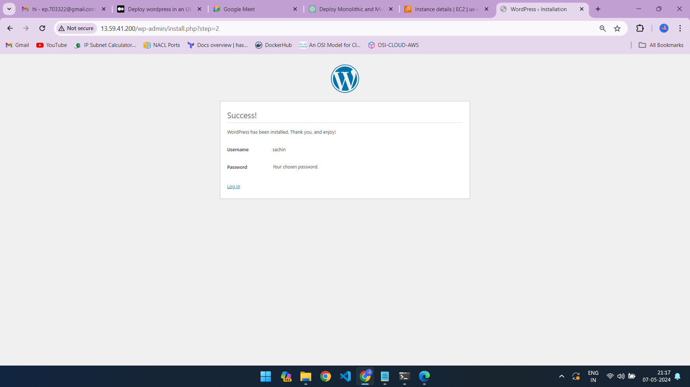

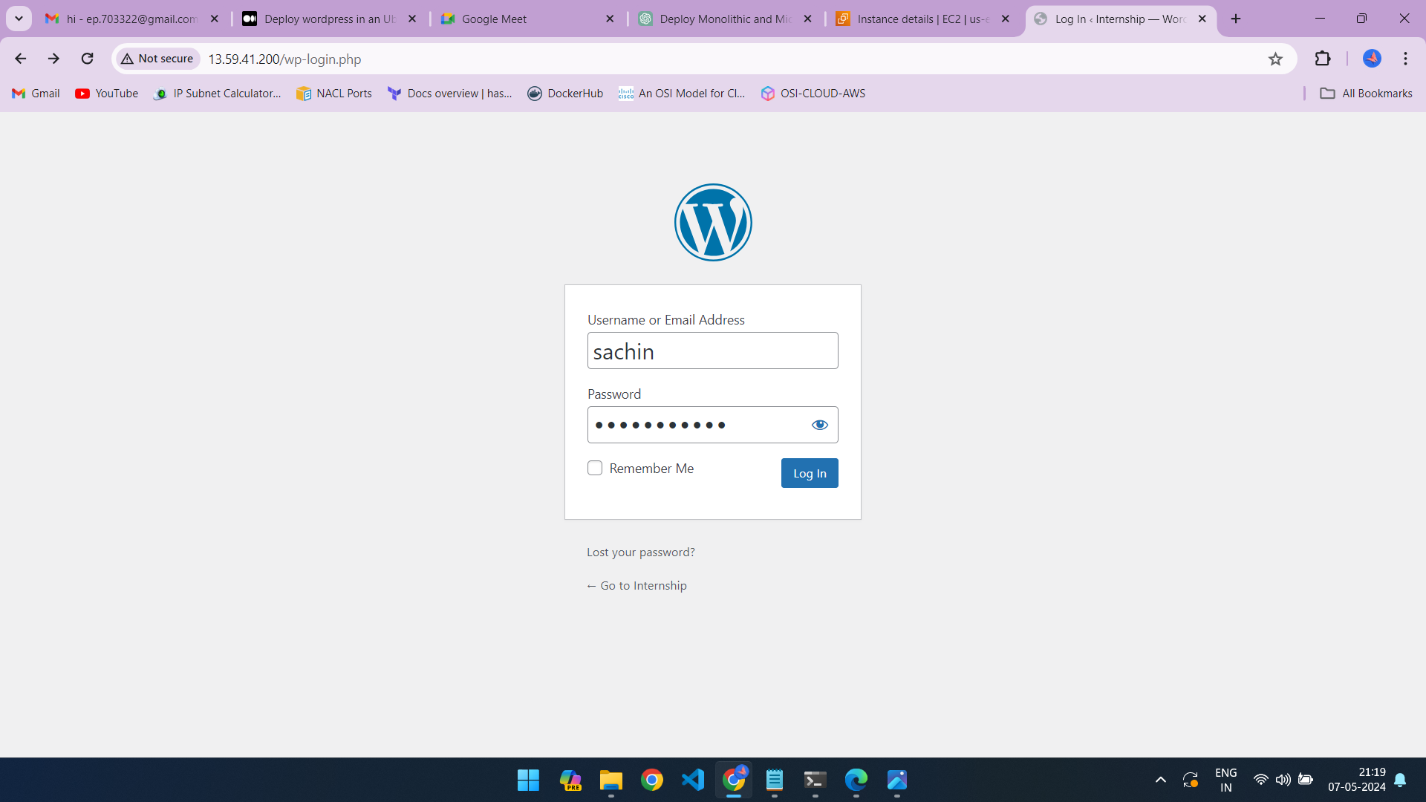

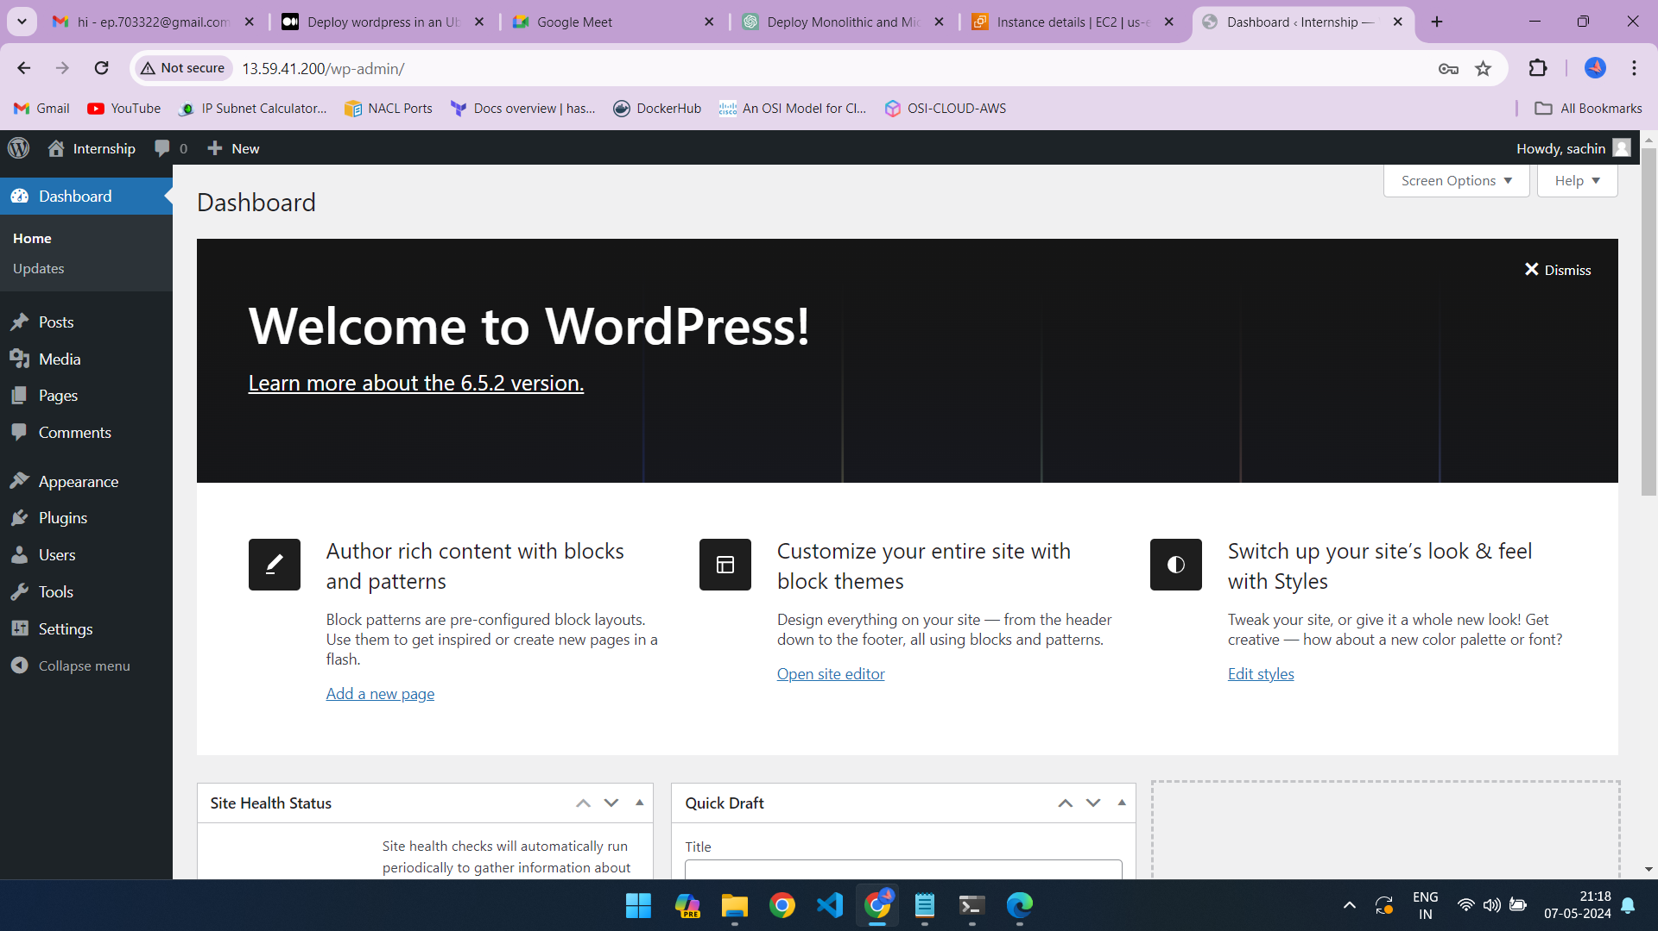

**Commands used:**

1. sudo apt update

2. sudo apt install apache2 mysql-server mysql-client php libapache2-mod-php php-mysql

3. sudo mysql_secure_installation

4. wget https://wordpress.org/latest.tar.gz

5. tar -xzvf latest.tar.gz

6. sudo cp -r wordpress/* /var/www/html

7. cd /var/www/html

8. sudo chown -R www-data:www-data /var/www/html/

9. ls

10. sudo rm -rf index.html

11. cd

12. sudo mysql -u root -p

13. sudo cp /var/www/html/wp-config-sample.php /var/www/html/wp-config.php

14. sudo nano /var/www/html/wp-config.php